Geospatial InfoTech Solutions:
DFD Diagrams:
Context 0th Level Diagram:

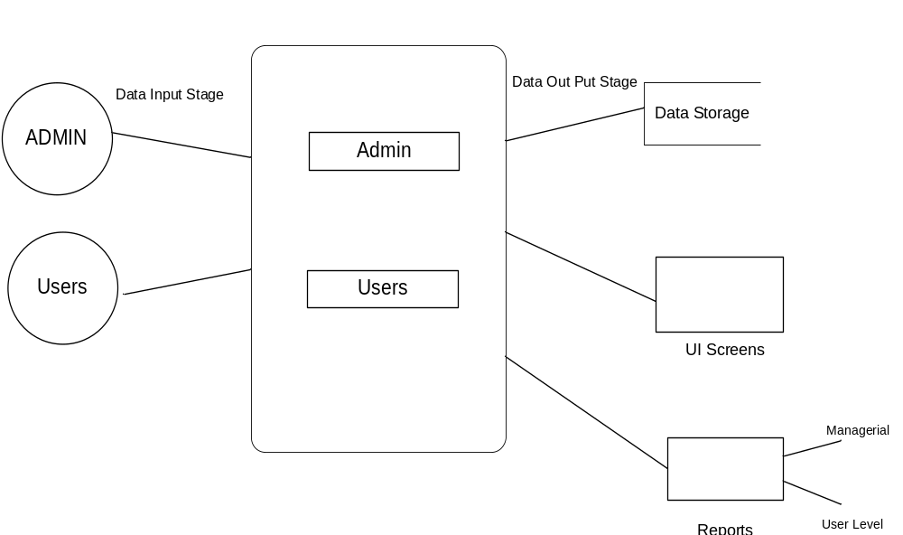
Login DFD Diagram:
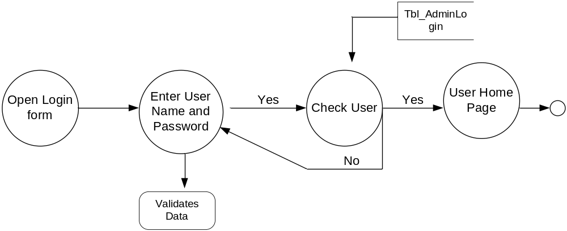

Admin Details Data Flow:
1st level DFD:
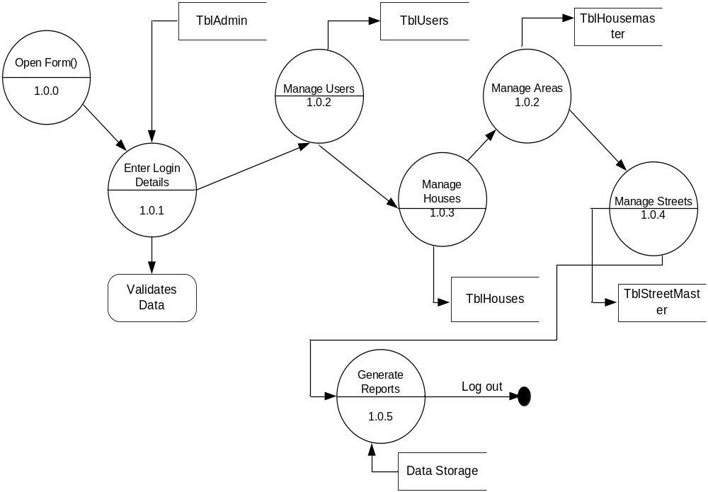2nd Level DFD
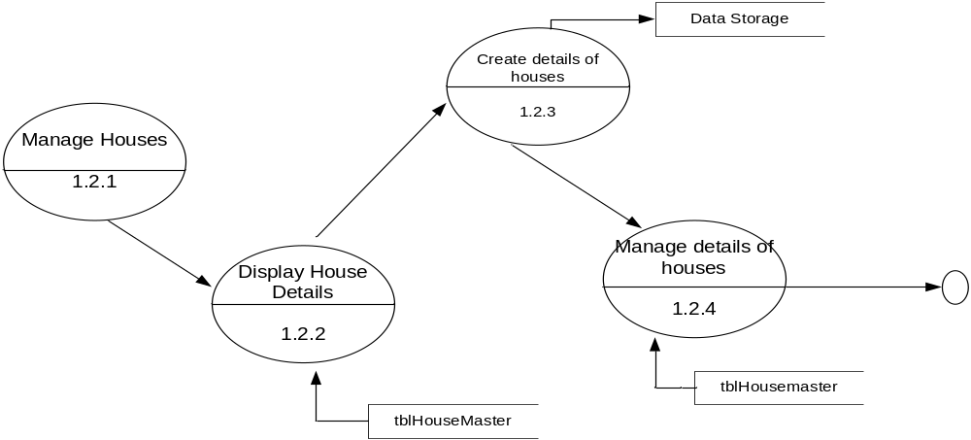

User Details Data Flow
1st level DFD

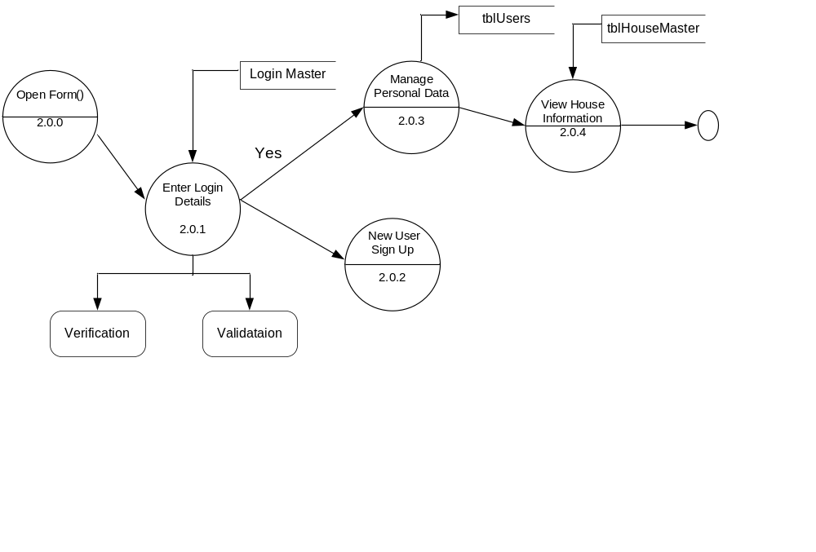
2nd level DFD
